Oni Music

Functional Decomposition Diagram (FDD)
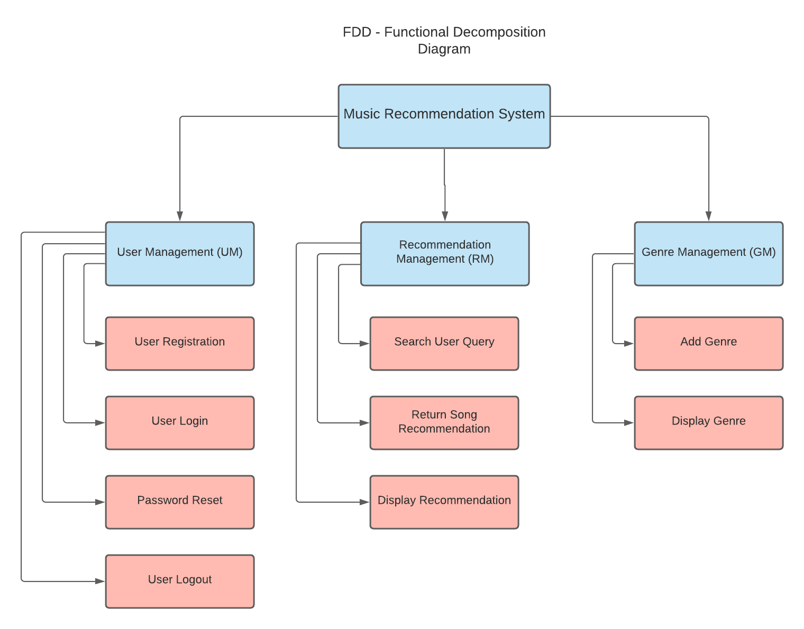
Figure 1: Functional Decomposition Diagram (FDD)

Software Requirement Specification (SRS)

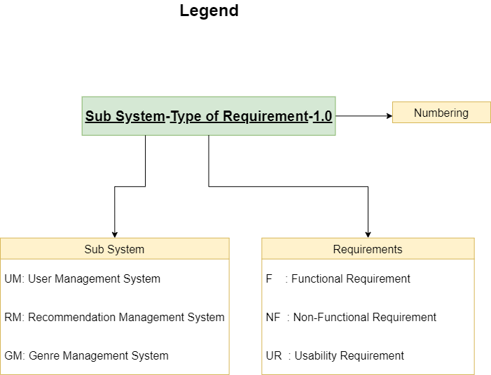

User Management System (UM)
Requirement Code | Requirement Description | Use Case | MoSCoW Prioritization
UM-F-1.0 | The system should allow user account creation. | Create User | Must have
UM-NF-1.1 | While creating a user, the username must be less than 150 characters and only include letters, digits and @/. /+/-/_ only. |  | Must have
UM-F-2.0 | The system should allow the user to Login to the system. |  | Must have
UM-F -2.1 | The user should be able to logout of the account that they are logged in. |  | Must have
UM-F-3.0 | The system should allow the user to reset their password. |  | Must have
UM-NF-3.1 | While resetting the user password, the user must be logged into the related account. |  | Must have

Recommendation Management System (RM)
Requirement Code | Requirement Description | Use Case | MoSCoW Prioritization
RM-F-1.0 | The system should allow the user to search for a track. | Create search query | Must have
RM-NF-1.1 | While searching, the user must insert the name of a song track. |  | Should have
RM-F-2.0 | The system should return song recommendation based on the user search query. |  | Must have
RM-NF-2.1 |  |  | Must have
RM-F-3.0 |  |  | Must have
RM-NF-3.1 |  |  | Must have

Genre Management System (GM)
Requirement Code | Requirement Description | Use Case | MoSCoW Prioritization
GM-F-1.0 | The system should display the genre list in an ordered manner whenever a request to /genre is made. | Create genre view | Must have
GM-F-2.0 | The system should allow the user to browse different genres and songs related to the specific genres |  | Must have
GM-NF-2.1 |  |  | Must have
GM-F-3.0 |  |  | Must have
GM-NF-3.1 |  |  | Must have

Activity Diagrams

User Management System

User Registration
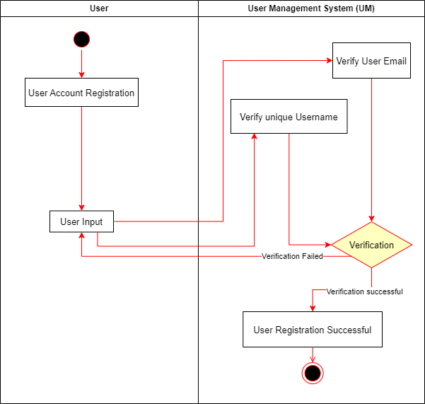

User Login
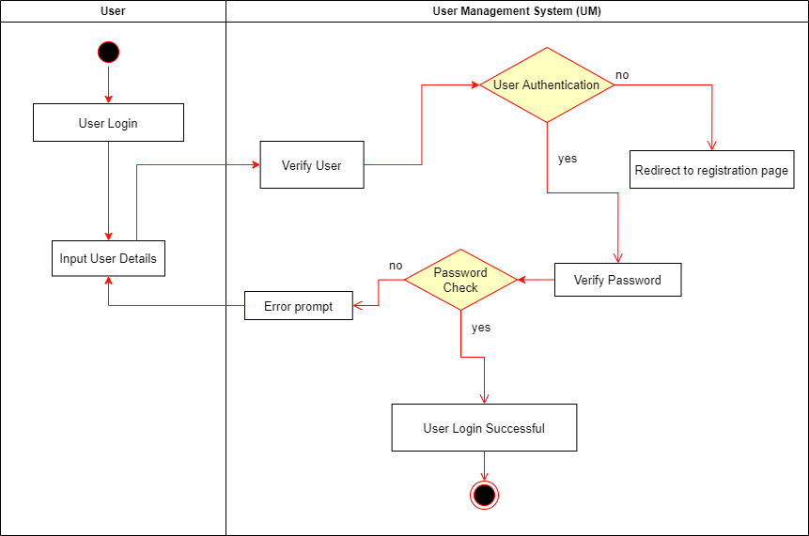

User Logout
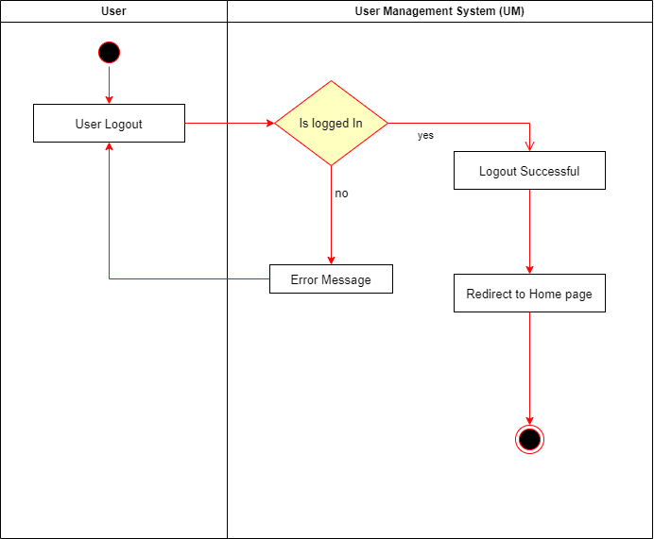

User Password Reset
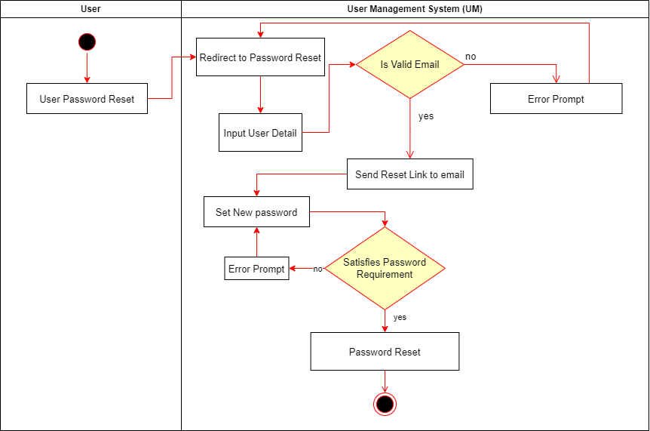

Recommendation Management System

Search Query
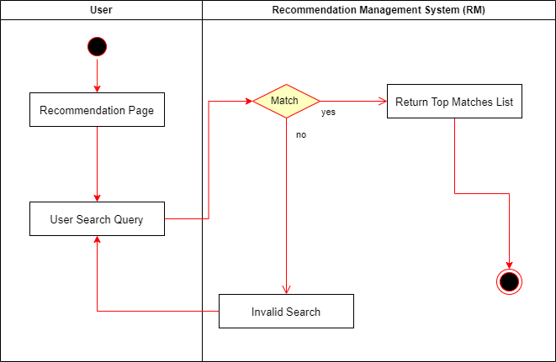

Song Recommendation
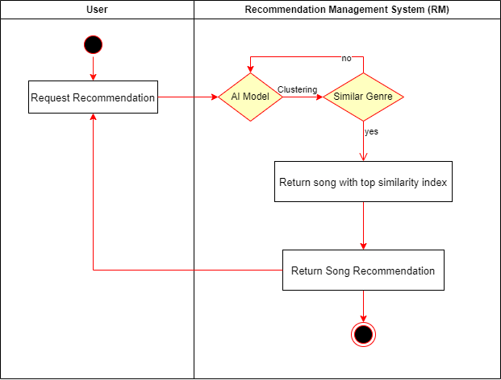

Genre Management System

